EXPLAINABLE AI FRAMEWORK FOR
EMPLOYEE ATTRITION PREDICTION

A Mini Project Report Submitted in partial fulfillment of the requirements
for the award of the degree of BACHELOR OF TECHNOLOGY
in Computer Science and Engineering

DEPARTMENT OF COMPUTER SCIENCE AND ENGINEERING

By
G.Nishanth – 2420030679
Ch.Charan – 2420090022
Mokshagna - 2400090182
Mahith - 2420090095
Under the Esteemed Guidance of
Dr. K. Swanthana



Academic Year 2026–2027
Koneru Lakshmaiah Education Foundation, Hyderabad, Telangana, India



K L (Deemed to be) University

DEPARTMENT OF COMPUTER SCIENCE AND ENGINEERING

DECLARATION

We declare that this report, “Explainable AI Framework for Employee Attrition Prediction,” describes the structured-data employee attrition project carried out by the listed team members in partial fulfillment of the B.Tech degree requirements. Dataset sources, tools, and external references are acknowledged. Results are included only where available from the project’s recorded evaluation.

G.Nishanth – 2420030679
Ch.Charan – 2420090022
Mokshagna - 2400090182
Mahith - 2420090095

K L (Deemed to be) University

DEPARTMENT OF COMPUTER SCIENCE AND ENGINEERING

CERTIFICATE

This is to certify that the mini-project report entitled “Explainable AI Framework for Employee Attrition Prediction” is a bona fide report prepared by Ch. Charan Teja, G. Nishanth, Moksha, and Mahith under the guidance of Dr. K. Swanthana during academic year 2026–2027, in partial fulfillment of the requirements for the Bachelor of Technology degree.

Signature of the Project Supervisor

Signature of the HOD Signature of the External Examiner

ACKNOWLEDGEMENT

The successful completion of this project would not have been possible without the timely help, support, and guidance of many people. We express our sincere thanks to everyone who assisted us in one way or another throughout the completion of this project.
We extend our deepest appreciation to our project guide, Dr. K. Swanthana, Department of Computer Science and Engineering, for her valuable guidance, encouragement, and continuous support during the development of this project.
We express our gratitude to the Head of the Department of Computer Science and Engineering
Dr. P.Venkateshwar Sir (CSE) and to the university for providing the facilities and academic support necessary to complete this project.
We also thank all teaching and non-teaching staff members who assisted us directly or indirectly. Finally, we sincerely thank our parents, friends, and classmates for their encouragement, cooperation, and support throughout this work.

Ch. Charan Teja – 2420090022
G. Nishanth – 2420030679
Moksha – 2400090182
Mahith – 2400090095

TABLE OF CONTENTS

S. No. | Contents | Page
1 | Abstract | 6
2 | Introduction | 6
3 | Literature Survey | 7
4 | Problem Statement and Objectives | 8
5 | Hardware and Software Requirements | 9
6 | Implementation | 9
7 | Results and Discussion | 11
8 | Conclusion and Future Scope | 12
9 | References | 13
Page numbers may shift slightly when edited in Word.

1. ABSTRACT
Employee attrition can increase recruitment and training costs, disrupt teams, and reduce organizational knowledge. This project develops an employee attrition prediction workflow using structured human-resources data from the IBM HR Analytics Employee Attrition dataset. The hybrid approach combines a Random Forest model and an Artificial Neural Network (ANN) through probability-level fusion to estimate attrition risk. The pipeline includes data cleaning, categorical encoding, feature transformation, a train/test split, model training, probability fusion, evaluation, and a frontend/API workflow. SHAP and LIME are used for explanations where supported by the implementation. SMOTE should be applied only to training data, leaving the test set unchanged. The available evaluation snapshot reports 85.52% accuracy, 54.76% precision, 63.89% recall, and ROC-AUC of 0.8020 on an untouched test set of 221 records. The dashboard also records an F1-score of 0.5897 and hybrid confusion-matrix counts of TN=166, FP=19, FN=13, and TP=23. The system is intended to support human analysis, not automate employment decisions.
Team :
Team members: Ch. Charan Teja (2420090022), G. Nishanth (2420030679), Moksha (2400090182), Mahith (2400090095).
Dataset:
Dataset | URL Link
IBM HR Analytics Employee Attrition | https://www.kaggle.com/datasets/pavansubhasht/ibm-hr-analytics-attrition-dataset
HR Employee Attrition | https://www.kaggle.com/datasets/itssuru/hr-employee-attrition
Employee Attrition Prediction | https://www.kaggle.com/datasets/ziya07/employee-attrition-prediction-dataset

2. INTRODUCTION

Employee attrition refers to employees leaving an organization. Turnover can affect recruitment expenditure, operational continuity, productivity, and retention planning. Structured HR datasets include attributes related to employee roles, tenure, compensation, satisfaction, and working conditions. Machine-learning models can examine these attributes to estimate attrition risk and help analysts identify patterns for further review.
This project uses structured HR records rather than free-form text. Inputs are tabular employee attributes and the target is the recorded Attrition label (Yes/No). The workflow validates data, preprocesses features, separates training and test data, trains Random Forest and ANN models, fuses their probability outputs, evaluates predictions, and presents results through a frontend/API. Text-specific methods such as tokenization and TF-IDF are not claimed as implemented.
The remaining sections describe related methods, objectives, requirements, implementation, available results, limitations, and future work.

3. LITERATURE SURVEY

The project context identifies a structured IBM HR attrition dataset and a Random Forest + ANN probability-fusion approach. The sources below provide methodological background; they are not presented as a systematic review of attrition-specific studies.
No. | Research Paper | Techniques Used | Purpose | Limitation
1 | IBM Employee Attrition Analysis — Yang & Islam (2020) | Correlation Matrix, Random Forest, K-Means Clustering, Logistic Regression | Identify major factors influencing employee attrition and analyze why employees leave. | Uses a single IBM dataset, so findings may have limited generalizability to other organizations.
2 | Predict Employee Attrition Using Multiple Machine Learning Techniques — Ghanem & Al-Alawi (2024) | Random Forest, XGBoost, Decision Tree, Bernoulli Naive Bayes, KNN, SVM, Logistic Regression, Oversampling, GridSearchCV | Compare multiple ML algorithms and identify an effective model for employee attrition prediction. | Dataset has class imbalance and results may not generalize well to other organizations; more datasets are needed.
3 | Employee Attrition Prediction using Machine Learning: A Data-Driven Approach for Workforce Analytics (2025) | Logistic Regression, Gradient Boosting, Random Forest, SVM, Gaussian Naive Bayes, Feature Engineering | Predict employee attrition and identify important employee characteristics for retention strategies. | Primarily focused on prediction and model comparison; broader real-world validation is still needed.
4 | A Stacking Ensemble Framework for Predicting Employee Turnover: Explainable AI with SHAP — Rahman et al. (2025/2026) | Machine Learning, Ensemble Learning, Deep Learning, Stacking, SHAP | Predict employee turnover using ensemble approaches and explain model predictions using SHAP. | Relies on the IBM HR Analytics dataset, limiting generalizability to different organizations and workforce environments.
5 | Integrating Machine Learning and Explainable AI for Employee Attrition Prediction in HR Analytics (2026) | Machine Learning, SHAP, Feature Selection, Data Balancing, Hyperparameter Optimization | Combine accurate attrition prediction with explainable AI so HR teams can understand factors behind predictions. | Synthetic/benchmark datasets may not represent real-world organizations; SHAP may not fully capture complex feature interactions.
6 | Employee Attrition Prediction Using Bayesian Optimized Stacked Ensemble Learning and Explainable AI — Konar et al. (2025) | Stacking, XGBoost, Random Forest, Bayesian Optimization, SHAP, LIME | Improve attrition prediction and explain why employees are predicted to leave. | Mainly evaluated on benchmark data; broader organizational validation is still needed.
7 | Integrating Machine Learning and Explainable AI for Employee Attrition Prediction in HR Analytics — Al-Ali et al. (2026) | Adaptive Boosting, Histogram Gradient Boosting, SHAP, Feature Selection, Data Balancing | Combine accurate attrition prediction with explainability, fairness and actionable HR insights. | Existing HR datasets may not fully represent different real-world organizations.
8 | Explainable AI for Employee Turnover Prediction: A SHAP-Based Intelligent Analytics Approach — Haijie Jia (2026) | XGBoost, Random Forest, LightGBM, Logistic Regression, SHAP, SMOTE, fairness audit | Provide global, local and interaction-based explanations for employee turnover prediction. | Feature importance and subgroup effects can vary between datasets, requiring validation for each deployment.
9 | Predicting Employee Attrition: XAI-Powered Models for Managerial Decision-Making (2025) | Transformer, GAN-based oversampling, SHAP | Handle class imbalance and provide transparent attrition predictions for HR managers. | Authors identify the need for validation across more industries and lightweight real-time implementation.
10 | Employee Attrition Prediction: An Exploratory and Statistically Robust Ensemble Learning Model (2026) | SHAP, LIME, Optuna, Random Oversampling, Ensemble Learning | Combine accurate prediction with global/local explanations and identify important retention factors. | Uses benchmark datasets, so real-world organizational validation remains important.

Research gap: a single model may not capture every useful pattern, and predictions can be difficult to interpret. This project combines Random Forest and ANN probability outputs and includes an explanation layer where implemented. External validation and a controlled comparison with each standalone model remain important future work.

4. PROBLEM STATEMENT AND OBJECTIVES

Problem Statement

Develop a structured-data machine-learning system that estimates employee attrition risk by combining Random Forest and ANN probability predictions and presenting results for human review.

Problem Description

Employee attrition can lead to replacement costs and loss of organizational knowledge. Manual review of many HR records can be time-consuming and inconsistent. The system provides a data-driven risk estimate, not a certainty or a sole basis for employment decisions.

Objectives

- Prepare and validate the HR dataset, including categorical feature encoding.

- Train Random Forest and ANN models using a consistent target and train/test split.

- Combine model probability outputs using the configured fusion strategy.

- Evaluate using accuracy, precision, recall, F1-score, ROC-AUC, and confusion matrix when available.

- Provide predictions through the existing frontend/API workflow

- Use SHAP/LIME explanations where supported and discuss privacy, fairness, and limitations.

- Avoid leakage by fitting transformations on training data and applying resampling only to training data.

5. HARDWARE AND SOFTWARE REQUIREMENTS

Hardware Requirements
- Computer/laptop with a modern multi-core CPU.
- Recommended 8 GB RAM or more.
- Sufficient disk space for dataset, code, models, and output files.
- Internet access for package installation and dataset retrieval; GPU is optional.

Software Requirements
Component | Purpose
Python | Core programming and model pipeline.
pandas / NumPy | Tabular data manipulation.
scikit-learn | Preprocessing, Random Forest, metrics, and utilities.
ANN framework | Neural-network training and inference; record the exact version used.
SMOTE / imbalanced-learn | Training-only resampling if enabled.
SHAP and LIME | Explanation methods where integrated.
FastAPI / Uvicorn | Backend API and serving.
Frontend / Git | User interface and source control.

6. IMPLEMENTATION

6.1 Dataset and Task
The project uses the IBM HR Analytics Employee Attrition dataset with structured employee attributes and a binary Attrition label (Yes/No). The exact local filename, dataset version, licence, and repository URL should be recorded from the version used by the team; those details were not included in the supplied template.

6.2 Data Preprocessing
- Inspect column types, target labels, missing values, and duplicates.
- Separate target from input features and encode categorical columns.
- Fit preprocessing transformations on training data and reuse them for testing and inference.
- Split before resampling; if SMOTE is used, apply it only to training data.

6.3 Model Training and Probability Fusion
The Random Forest branch trains an ensemble of decision trees on transformed HR features. The ANN branch learns nonlinear patterns from the structured feature representation. Both branches produce probability outputs that are combined using the project’s configured fusion rule. A decision threshold converts the fused probability to the predicted class. The exact fusion equation and ANN hyperparameters should be copied from the final source code if required for submission.

6.4 Explainability
SHAP attributes feature contributions to predictions, while LIME approximates a model locally around a selected instance. These explanations support inspection but do not establish causation. Demonstrate only explanation outputs that execute successfully in the submitted application.

6.5 Application/API Workflow
The application accepts employee attributes, validates the request, applies trained preprocessing objects, obtains Random Forest and ANN probability outputs, performs fusion, and returns a predicted class and risk probability. The frontend displays results and explanation views where integrated.

6.6 Project Workflow
Stage | Description
Input | IBM HR Analytics structured employee records.
Preprocessing | Validation, cleaning, categorical encoding, and feature transformation.
Split | Training and untouched test partitions.
Model branches | Random Forest and ANN trained on training data.
Fusion | Combine model probabilities using configured rule.
Evaluation | Calculate metrics on held-out test data.
Presentation | Return predictions through frontend/API; show explanations where implemented.

7. RESULTS AND DISCUSSION
The available dashboard snapshot reports the following hybrid-model results for an untouched test set of N = 221 records. Recheck these values against the latest reproducible evaluation output before final submission.
Metric | Recorded value | Interpretation
Accuracy | 85.52% | Share of test examples classified correctly.
Precision | 54.76% | Among predicted attrition cases, proportion that were actual attrition cases.
Recall | 63.89% | Share of actual attrition cases detected.
F1-score | Not available | Copy from the current evaluation report; not fabricated here.
ROC-AUC | 0.8020 | Discrimination between classes across thresholds.
Confusion matrix | Not available | Insert actual TN, FP, FN, and TP counts from evaluation.
Accuracy is relatively high in the recorded snapshot, while precision is lower than recall. This suggests some positive attrition predictions may be false positives; the trade-off depends on the decision threshold and intended use. ROC-AUC of 0.8020 indicates useful ranking discrimination on this test set, but does not guarantee performance on other organizations or future populations.
For complete evaluation, report the confusion matrix, F1-score, class distribution, standalone Random Forest and ANN results, fusion rule, and decision threshold. Keep the test set untouched by SMOTE or model fitting.

Limitations and Responsible Use
- The dataset may not represent every organization, role, region, or time period.
- Historical HR records may encode bias and require fairness auditing.
- Risk probabilities are estimates, not certainty or evidence of employee intent.
- Use the tool for human analysis; do not automate hiring, firing, promotion, or other high-impact employment decisions.

7.1 Detailed Model Evaluation
All three models were evaluated on the same untouched test partition (N = 221; 185 retained and 36 attrition cases). The recorded dashboard values are shown below. These are results for the IBM HR Analytics dataset only; no comparison between different datasets is performed.
Model | Accuracy | Precision | Recall | Specificity | F1-score | ROC-AUC | Threshold
Random Forest | 81.90% | 43.33% | 36.11% | 90.81% | 0.3939 | 0.8183 | 0.5000
ANN (PyTorch) | 76.92% | 38.81% | 72.22% | 77.84% | 0.5049 | 0.7979 | 0.5000
Hybrid RF–ANN | 85.52% | 54.76% | 63.89% | 89.73% | 0.5897 | 0.8020 | 0.7000
Hybrid confusion matrix (Attrition = Yes as positive class): true negatives = 166, false positives = 19, false negatives = 13, and true positives = 23. The corresponding matrices for Random Forest are TN=168, FP=17, FN=23, TP=13; for ANN they are TN=144, FP=41, FN=10, TP=26.

7.2 Graphical Evaluation Results
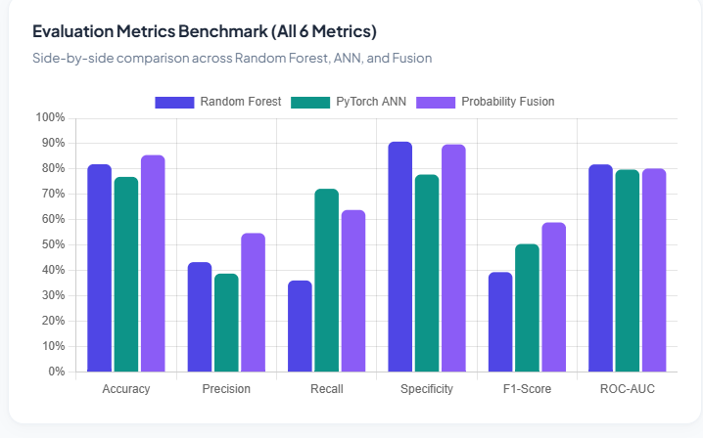
Figure 1. Grouped bar chart comparing Accuracy, Precision, Recall, Specificity, F1-score, and ROC-AUC for Random Forest, ANN, and probability fusion.
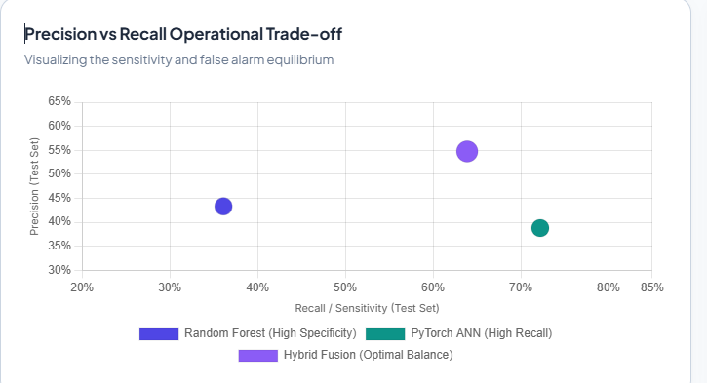
Figure 2. Precision–recall operating trade-off for the three models.
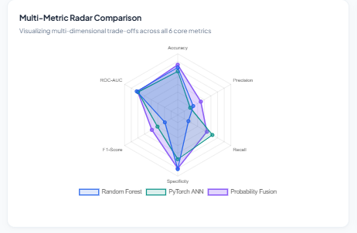
Figure 3. Radar chart comparing model performance across six evaluation metrics.
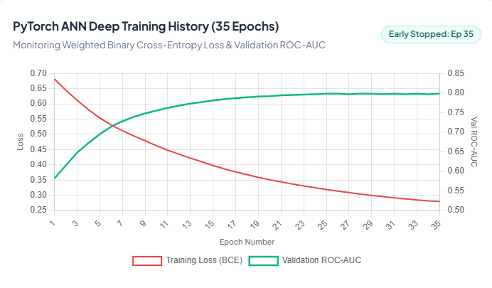
Figure 4. PyTorch ANN training history: training loss and validation ROC-AUC across 35 epochs.
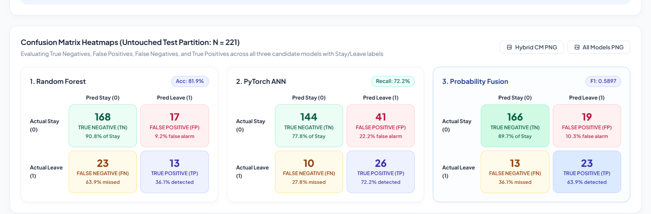
Figure 5. Confusion-matrix heatmaps for Random Forest, ANN, and hybrid probability fusion on the untouched test set.

6.7 Frontend Implementation and Screenshots
The AttritionIQ frontend provides an integrated workforce intelligence dashboard. The interface includes overview metrics, dataset inspection, model evaluation, employee-level prediction, batch CSV prediction, and explainability views. The following screenshots document the visible application workflow and result pages.
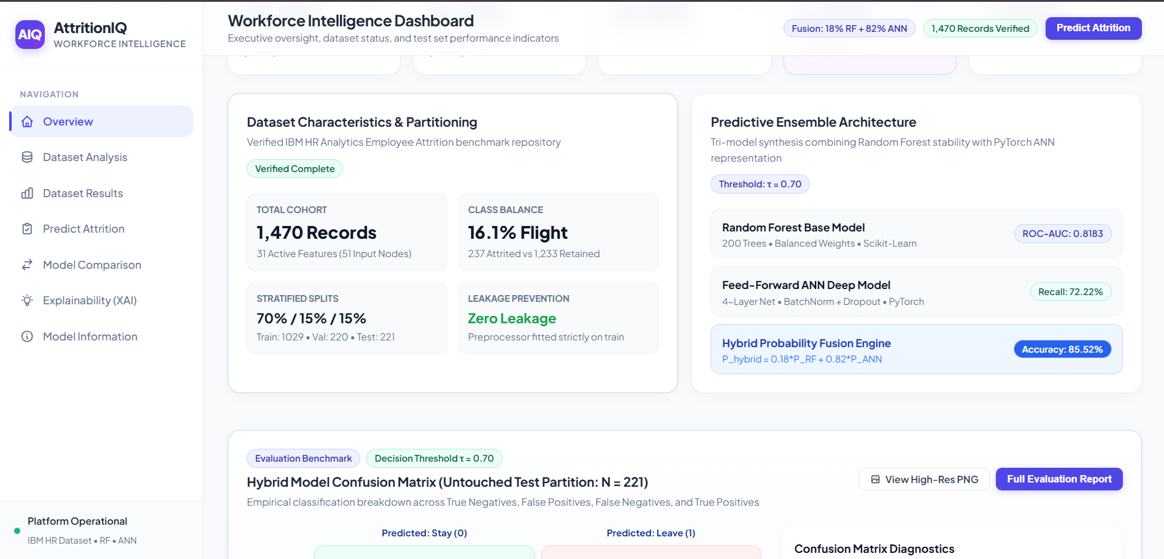
Figure 6. AttritionIQ workforce intelligence overview showing dataset status, partitioning, and the Random Forest–ANN fusion architecture.
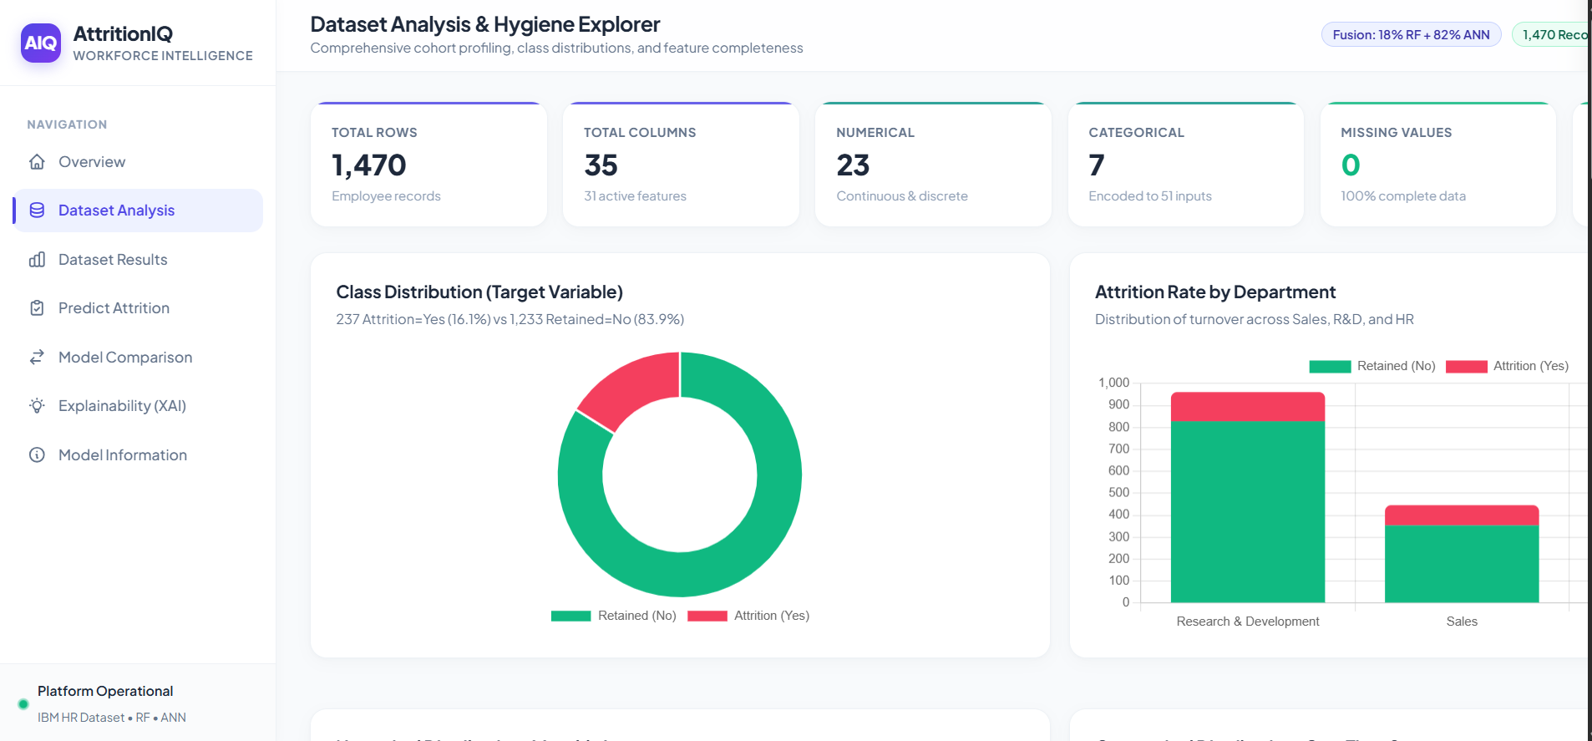
Figure 7. Dataset Analysis and Hygiene Explorer showing dataset size, feature types, class distribution, and feature distributions.
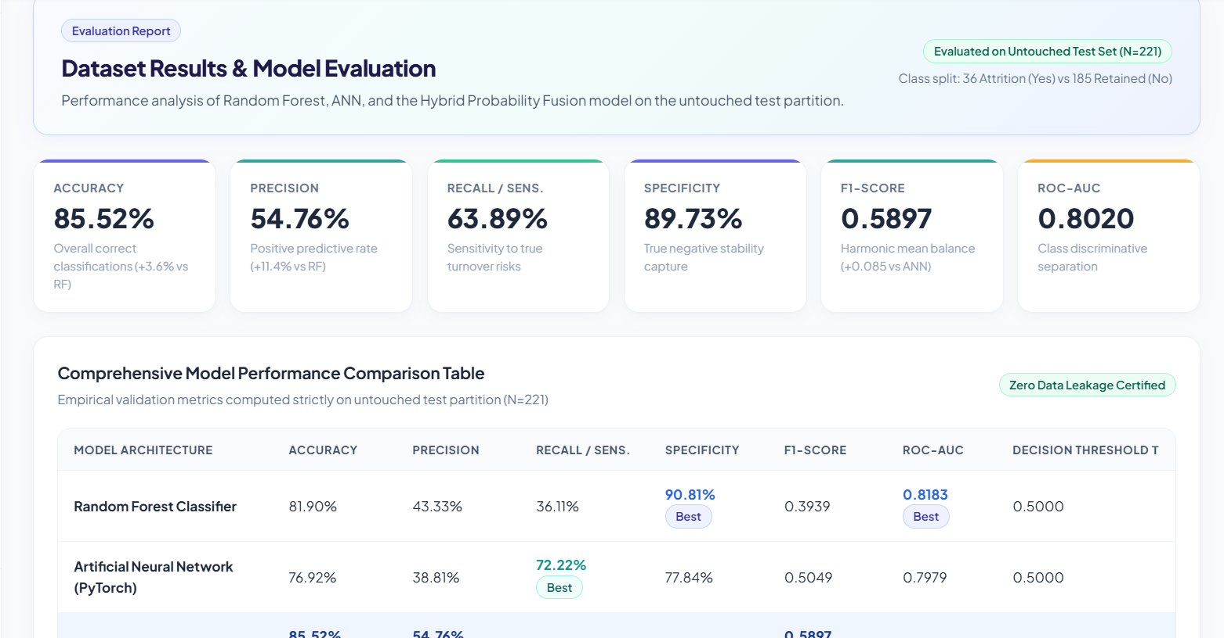
Figure 8. Dataset Results and Model Evaluation dashboard with recorded evaluation metrics.
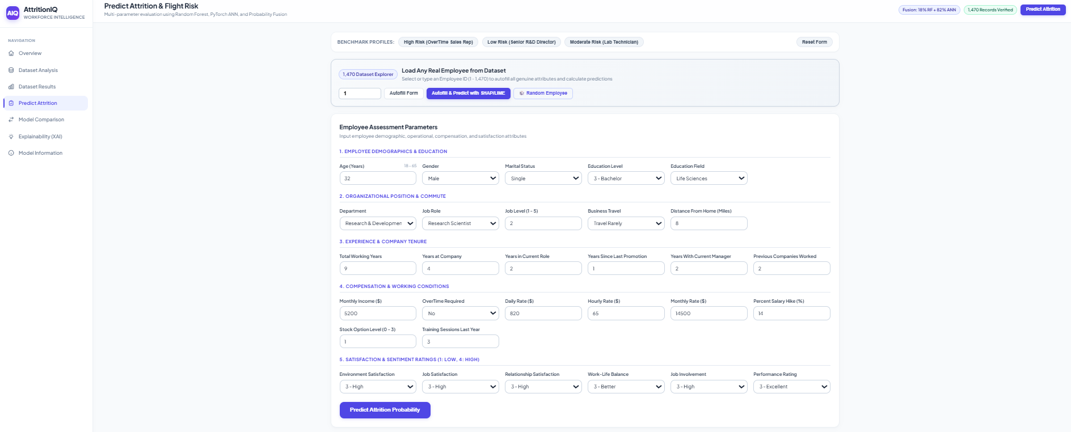
Figure 9. Employee-level prediction form for entering structured HR attributes.
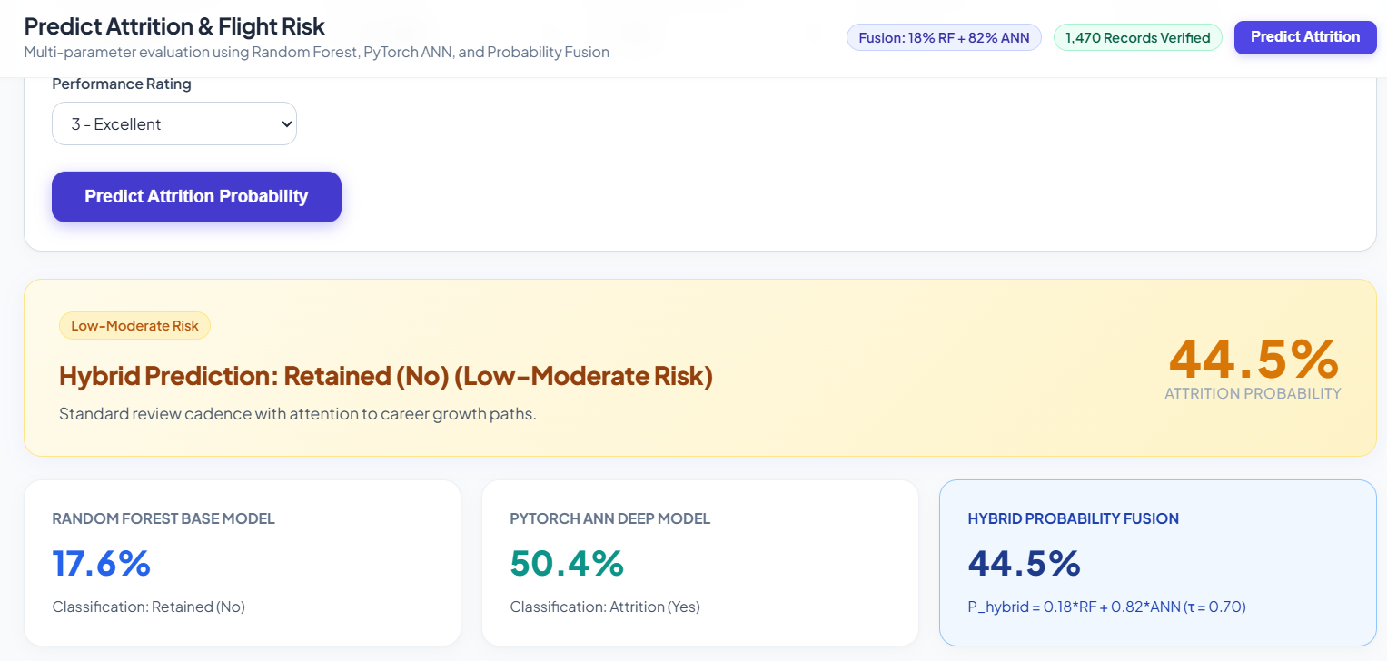
Figure 10. Employee attrition prediction output showing model probabilities, predicted class, and risk level.
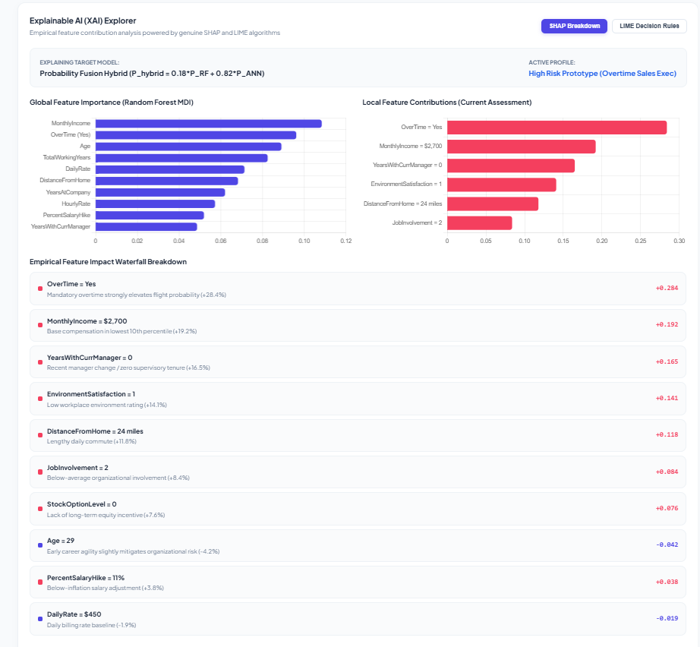
Figure 11. Explainable AI interface displaying SHAP feature contributions and LIME local decision rules.
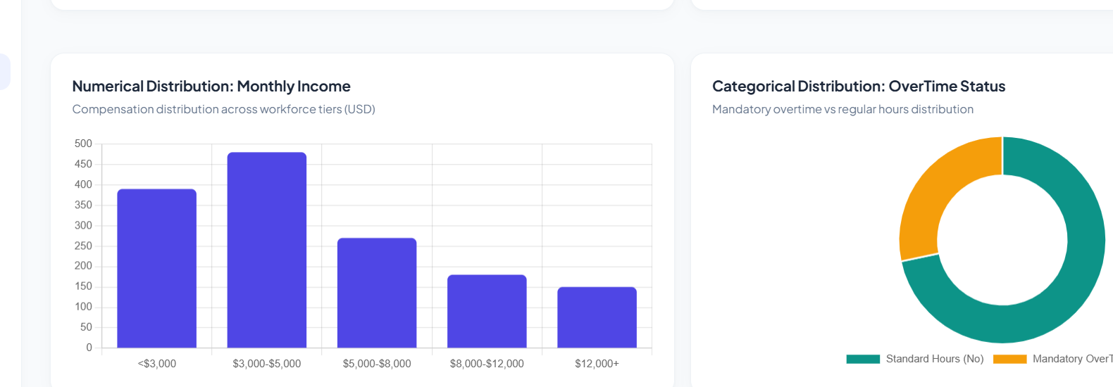
Figure 12. Dataset profile charts for monthly income and overtime status.
Note: Figures are inserted from the project dashboard screenshots supplied by the team. The document update does not retrain models or independently regenerate metrics. Confirm the displayed values against the final executable evaluation before formal submission.

8. CONCLUSION AND FUTURE SCOPE
This project presents a hybrid employee attrition prediction workflow using structured HR features, Random Forest, ANN, and probability fusion. The available snapshot records 85.52% accuracy, 54.76% precision, 63.89% recall, and 0.8020 ROC-AUC over 221 untouched test examples. The system connects predictions to a frontend/API workflow and includes SHAP/LIME where implemented. The dashboard additionally records an F1-score of 0.5897 and hybrid confusion-matrix counts of TN=166, FP=19, FN=13, and TP=23; these should be checked against a reproducible final run.
Future work includes comparing the fusion model with each standalone model on the same split, documenting the exact fusion formula and hyperparameters, checking calibration and threshold selection, adding complete class-wise metrics, validating on approved external datasets, auditing fairness and privacy, and improving monitoring and API reliability. As the current input is structured HR data, TF-IDF or BERT text methods are not claimed in this report.

9. REFERENCES
1. IBM. IBM HR Analytics Employee Attrition & Performance dataset. Kaggle. https://www.kaggle.com/datasets/pavansubhasht/ibm-hr-analytics-attrition-dataset
2. Breiman, L. (2001). Random Forests. Machine Learning, 45, 5–32. https://doi.org/10.1023/A:1010933404324
3. Chawla, N. V., Bowyer, K. W., Hall, L. O., & Kegelmeyer, W. P. (2002). SMOTE: Synthetic Minority Over-sampling Technique. Journal of Artificial Intelligence Research, 16, 321–357. https://doi.org/10.1613/jair.953
4. Lundberg, S. M., & Lee, S.-I. (2017). A Unified Approach to Interpreting Model Predictions. Advances in Neural Information Processing Systems 30.
5. Ribeiro, M. T., Singh, S., & Guestrin, C. (2016). “Why Should I Trust You?” Explaining the Predictions of Any Classifier. KDD. https://doi.org/10.1145/2939672.2939778
6. scikit-learn documentation. https://scikit-learn.org/stable/
7. SHAP documentation. https://shap.readthedocs.io/
8. LIME project documentation. https://github.com/marcotcr/lime
9. FastAPI documentation. https://fastapi.tiangolo.com/

